Pin Layout of Motorized Lab Jack

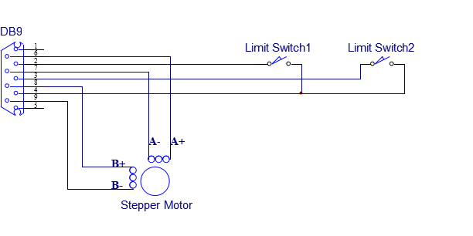

Limit Switch 1 is at the end of the stepper motor. It’s the home (zero) position.

Limit Switch 2 is at the opposite end of the stepper motor.