Pin Layout of Motorized Rotation Stage with Hall-Effect Switch

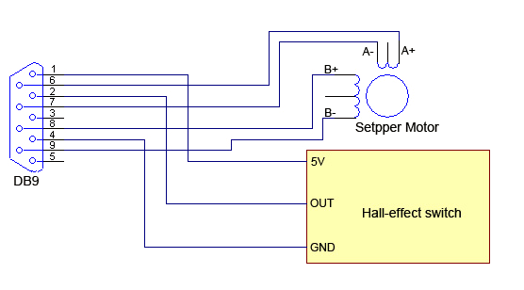

Input voltage of hall effect switch: 5V

Working current of hall effect switch: 20mA

The Hall Effect Sensor is active low and the output has a pull-up resistor.

If you don’t need the zero position, please cut off the wire of pin 2.