Pin Layout of Motorized Linear Stage

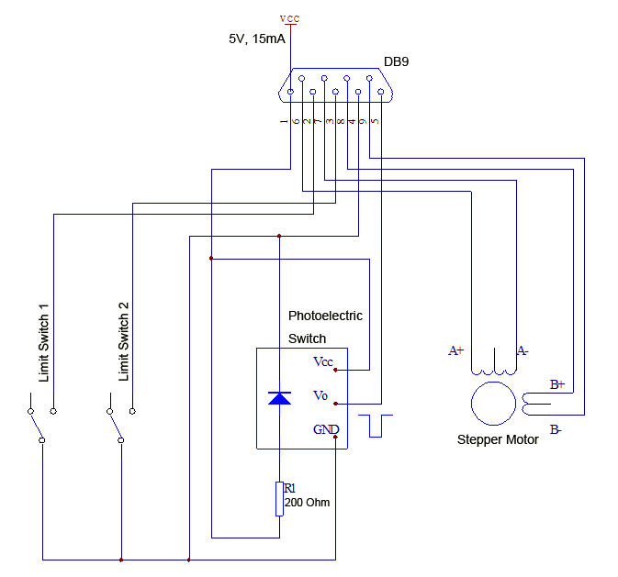

Limit Switch 1 is at the opposite end of the stepper motor. It’s the home (zero) position.

Limit Switch 2 is at the end of the stepper motor.

If you want to set Limit Switch 2 as the Zero position, please exchange the wiring of pin 6 and pin7, pin 2 and pin3.

Pin2 and pin3 are weak pull-up and pin4 is grounding. Pin2 and pin3 are normally high level. When they are active, they will be short circuit and grounding, and then they will change to active low.

The Photoelectric Switch is at the end of the stepper motor near the Limit Switch 2 and is active-low. The sink current is 1mA.

The Photoelectric Switch is just reserved for users. It’s not used by our controller.