Pin Layout of Motorized Integrated XY Stage

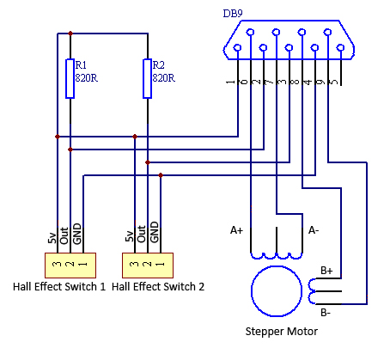

Hall Effect Switch 1 is at the opposite end of the stepper motor. It’s the home (zero) position.

Hall Effect Switch 2 is at the end of the stepper motor.

Input voltage of hall effect switch: 5V

Working current of hall effect switch: 20mA

The Hall Effect Sensor is active low and the output has a pull-up resistor.